**WEB DESIGN LAB 1**

**TASK1:**

This task is designed to help you, as a web designer student, put your design knowledge into practice by building a complete HTML web page that visually matches a provided picture. This exercise strengthens your understanding of how HTML elements work together to form the visual foundation of a webpage before styling is applied.

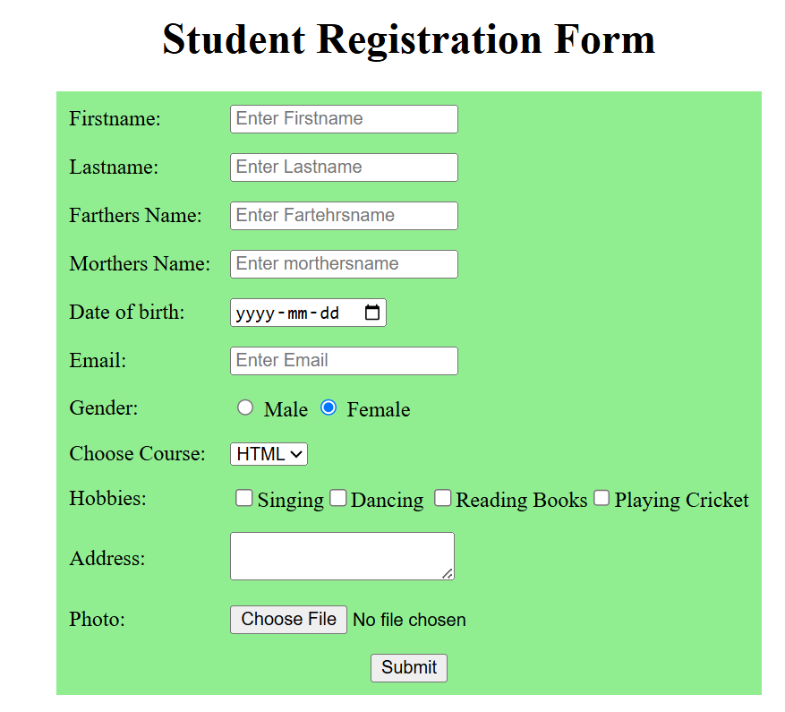

**Task2:**  
Create a complete HTML web page titled **"Customer Profile"** that displays and collects customer information. Your page must demonstrate the following HTML skills:

1. **DOCTYPE declaration** to define the HTML version.
2. **HTML structure** with <head> and <body> sections.
3. A **title** for the page in the browser tab.
4. A **main heading** introducing the page.
5. A **paragraph** explaining the purpose of the page.
6. A **profile image** of a sample customer.
7. A **list** of the customer’s preferences or interests.
8. A **table** showing sample customer data (e.g., Name, Email, Gender, Location).
9. A **feedback form** to collect personal information from the customer:

* Full Name
* Email
* Gender (radio buttons)
* Date of Birth
* Favorite Services (checkboxes or dropdown)
* Upload profile picture
* Additional feedback or comments (textarea)